**STARFIGHTER GAME - FINAL PROJECT**

**Lab Goal :** This lab was designed to teach you more about OOP and using Abstract Classes and Interfaces.

**Lab Description :** Write a first person shooter game. You are the StarFighter and your job is to destroy all of the enemies that enter your space. The StarFighter ship and enemy ships will share lots of the same properties. This lab provides the perfect opportunity to use inheritance, abstract classes, and interfaces. You will also review ifs, loops, and ArrayList / Matrices.

**Task One** – Write the MovingThing class. MovingThing will implement the Moveable interface. Make sure you think it through and that it compiles. Test it thoroughly.

**Task Two** – Extend the MovingThing class to make the Ship class.

**Task Three** – Use the Shiptest class and then the StarFighter and OuterSpace classes to test the Ship class. The Ship should move all around the screen in all 4 directions. Instantiate your ship at 310,450 with a speed of 5.

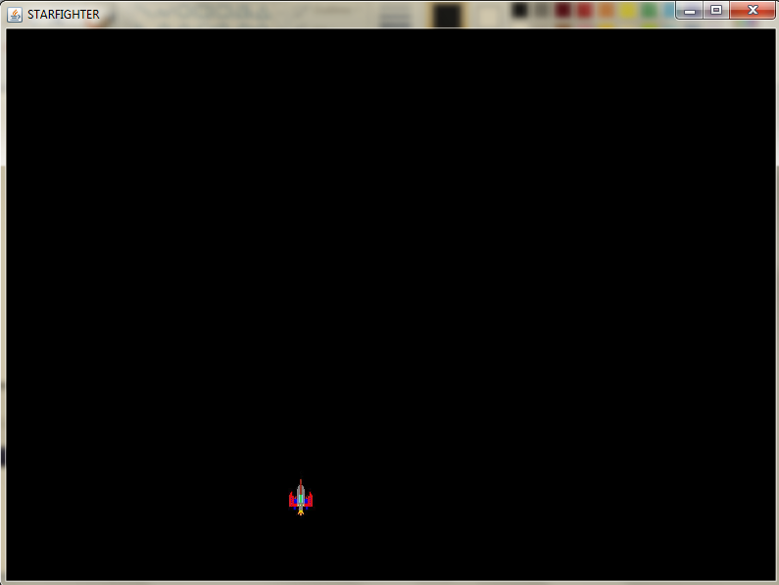

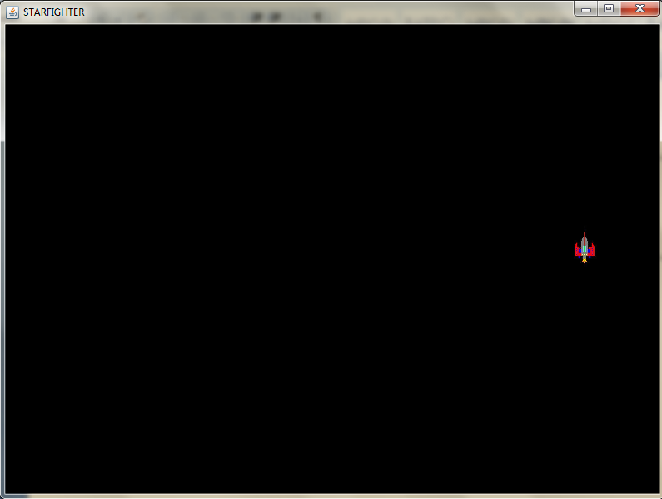

**KEYS TO CONTROL THE SHIP**

**left arrow - left**

**right arrow - right**

**up arrow - up**

**down arrow - down**